TYPE TITLE HERE IN ALL CAPS

___________

An Honors Thesis
Presented to
The Faculty of the Department <Insert Department Name>
Sam Houston State University

___________

In Partial Fulfillment
of the Requirements for the Degree of
Bachelor of <insert degree>

___________

by
<Your official name as found in the Registrar’s office>
<Insert month and year (e.g. May 2016)>
TYPE TITLE HERE IN ALL CAPS

by
<Your official name as found in the Registrar’s office>

___________

APPROVED:

<Insert Director’s Name>, Ph.D.
Director

Dr. Kimberly Bell, Ph.D.
Dean, Elliott T. Bowers Honors College

DEDICATION
Start typing your text here.

ABSTRACT
Student, Isaac M., The title of the thesis goes here: Use sentence style capitalization. Bachelor of Arts (<Insert Major Here>), December, 2016, Sam Houston State University, Huntsville, Texas.

This is the format for the bibliographic information required for the abstract. The content of the abstract that follows this citation will vary according to the subject area. The abstract should be concise and informative; however, the abstract must be less than 350 words in length. Students should consult their thesis director and style manual to determine the content of the abstract. In general, it should state the purpose and describe the subjects and the methodology used in the study. The abstract should also describe the findings, conclusions, and implications of the study.
A list of key words must be included at the bottom of the abstract; however, key words and the title information do not count toward the 350-word total. Key words should be specific terms or phrases used in the thesis that would enable a person to successfully search out the content of the document if it were in a library database. If one of the key words is a proper noun, follow the normal rules of capitalization. Likewise, italicize or underline foreign words or appropriate scientific nomenclature. The first word of each key term should be capitalized.
KEY WORDS: Thesis guidelines, Index word, Sam Houston State University, Graduate School, Texas.

ACKNOWLEDGEMENTS
Type your text here.

PREFACE
Type your text here. In one or two paragraphs, explain how you became interested in your thesis topic, how you chose your thesis director, how you devised and developed your research agenda.

TABLE OF CONTENTS
Page
DEDICATION iii
ABSTRACT iv
ACKNOWLEDGEMENTS v
PREFACE vi
TABLE OF CONTENTS vii
LIST OF TABLES ix
LIST OF FIGURES x
CHAPTER I 1
Introduction 1
Official SHSU Directions 1
Style Manuals 1
CHAPTER II 3
Heading Levels 3
First Heading Level 2 Subdividing Chapters into Main Sections 3
CHAPTER III 5
This is the Title for Chapter III 5
CHAPTER IV 7
This is the Title for Chapter IV 7
REFERENCES 8
APPENDIX 9
CURRICULUM VITAE 10

LIST OF TABLES

Table Page
- This is the Title for Table 1: Ferret Breeders of Ohio, New Jersey, and Washington States 3

LIST OF FIGURES
Page
Figure 1. The Figure Title Appears Beneath the Image. 5

CHAPTER I

Introduction

Official SHSU Directions
- These guidelines specify directions for undergraduate students who are submitting an honors thesis in partial fulfillment of degree requirements.
- Students should consult their thesis directors as to the required style manual.
- Students should avoid using another thesis as a model.
- Because of the updating of style manuals and SHSU honors thesis guidelines, what was accepted in the past may now be unacceptable.
- The thesis will be evaluated according to the current declared style manual and the current SHSU thesis guidelines.

Style Manuals
The following style manuals have been accepted by the Sam Houston State University Graduate Council. The most recent edition of these manuals should always be followed. Consult your thesis director to determine which manual is required by your department.
- ACS Style Guide: A Manual for Authors and Editors (American Chemical Society)
- AIP Style Manual (American Institute of Physics)
- Associated Press Stylebook and Libel Manual
- Chicago Manual of Style OR A Manual for Writers of Term Papers, Theses, Dissertations (Kate L. Turabian)
- Form and Style: Theses, Reports, Term Papers (William G. Campbell)
- A Manual for Authors of Mathematical Papers (American Mathematical Association)
- MLA Handbook for Writers of Research Papers (Modern Languages of America)
- Publication Manual of the American Psychological Association (APA)
- Scientific Style and Format: THE CSE Manual for Authors, Editors and Publishers (Council of Science Editors)
- Style Manual for Political Science (American Political Science Association - APSA)
- Style Manual: An official guide to the form and style of Federal Government printing (United States Government Printing Office)
- Suggestions to Authors of the Reports of the United States Geological Survey
- The Bluebook: A Uniform System of Citation (Harvard Law Review)

CHAPTER II

Heading Levels
This template has pre-formatted font styles that can be found in the Quick Styles gallery under the Home tab. The SectionTitle font style is used to type section titles like Chapter I, Appendix, and Curriculum Vitae. Heading 1 is used to type chapter titles that appear directly beneath the section titles, such as Introduction above. Using proper font styles ensures that the Table of Contents, List of Tables, and List of Figures are populated with correct information.

First Heading Level 2 Subdividing Chapters into Main Sections
Type your text here.

Heading Level 3 subdividing main sections into subsections.
Start typing text here. You may need to insert a style divider after the Heading Level 3. You can do this by placing your cursor after the Heading Level 3 and pressing the following buttons at the same time: CTRL + ALT + ENTER. Then you may switch to a different font style such as Normal.

Heading Level 4 subdividing Heading Level 3 sections into subsections.
Start typing your text here.
  - Heading Level 5 subdividing Heading Level 4 sections into subsections.
Start typing your text here. You do not have to use all of these heading levels in your document. Just remember that you must use them in order. You cannot skip from Heading Level 2 to Heading Level 4.
Also remember that you cannot have a single section or subsection. You must have at least two or more sections or subsections, otherwise you may as well not subdivide the text with a heading. It’s the same concept as creating an outline, if that helps.

CHAPTER III

This is the Title for Chapter III
Starting typing text here. This is the first paragraph of this chapter and contains lots of valuable information about data collected during this research project. Table 1 clearly presents the data collected for this project in a single, easy-to-read format. The author must reference the table before it appears in the text. Use the TableTitle font style found in the Quick Styles gallery on the Home tab to type the table’s title.
Table 1
This is the Title for Table 1: Ferret Breeders of Ohio, New Jersey, and Washington States
 | State | Membership Association | Bloodlines
Fire Storm Ferrets | Ohio | American Ferret Association  Heart of Ohio Ferret Association | American  Australian  Swedish  English  German
Four Paws Wrecking Crew Ferretry | Ohio |  | German  Finnish  English
Fuzzy Loving Ferrets | New Jersey |  | French  Danish  Austrian  Finnish  Scottish  English  German  Swedish  New Zealand  Russian  Welsh  Norwegian  Canadian  Angora
Ferretown USA | Washington |  | Unknown
Note: Notes for tables go beneath the tables and may be single-spaced to help differentiate them from regular text.
Tables should be cleanly formatted with the fewest number of horizontal and vertical lines used to separate the elements. Font size and spacing within a table can be adjusted to help with spacing issues or to keep a table on one page, as long as the text remains readable.

CHAPTER IV

This is the Title for Chapter IV
Starting typing text here. This is the first paragraph of this chapter and contains lots of valuable information about data collected during this research project. Figure 1 demonstrates a part of the research process. The author must reference the figure before it appears in the text. Use the FigureTitle font style found in the Quick Styles gallery on the Home tab to type the figure’s title.
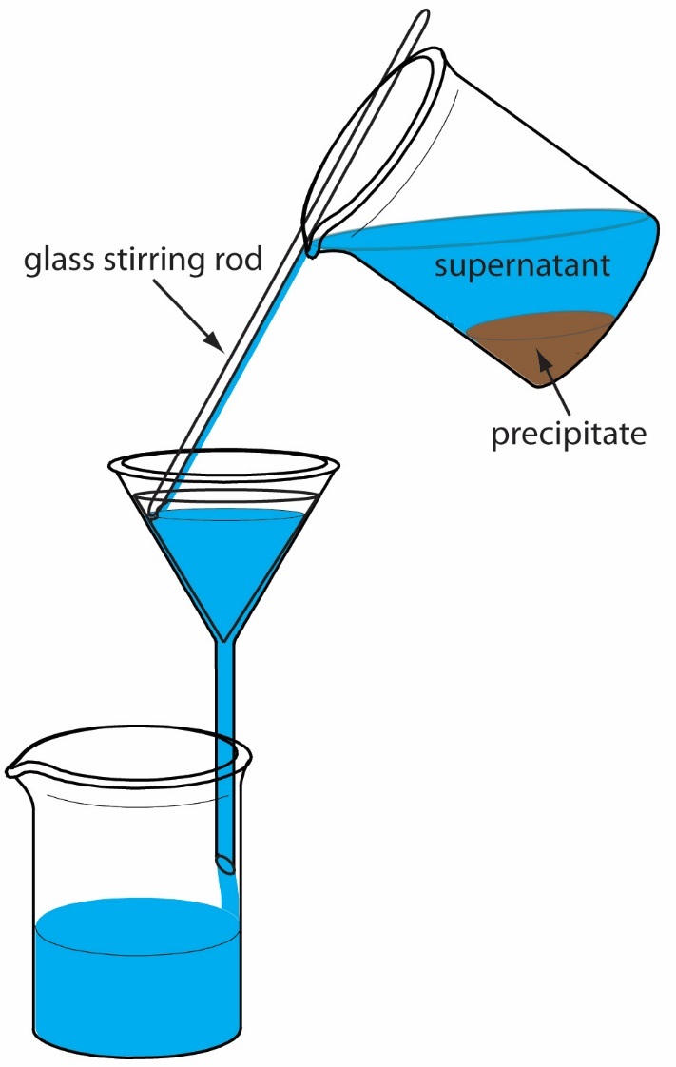
Figure 1. The Figure Title Appears Beneath the Image.
Notes are typed immediately after the caption. Captions and notes can be single spaced to help differentiate them from the rest of the test. You may also need to press CTRL + ALT + ENTER to separate the different font styles from each other on the same line.

REFERENCES

APPENDIX
Appendices serve as repositories for materials that help clarify your research, but do not belong in the main text. It is not required to include an Appendix. Include one or more only if you need to.
Items that might be included:
- Letters granting permission to reproduce or adapt images, instruments for research, or other copyrighted materials in your thesis/dissertation.
- Copies of IRBs.
- Survey questionnaires that you have created.
- Tables, figures, or instruments that do not belong in the main text.

CURRICULUM VITAE
A Curriculum Vitae (CV) is the equivalent of a resume and is used to list your educational and professional qualifications. There is no required format for this style. Instead, you may arrange the contents in the manner that best suits your academic field as long as the general format for theses and dissertations is followed.
Your CV may follow one of two formats:
•Narrative
•Traditional CV (resume) style

